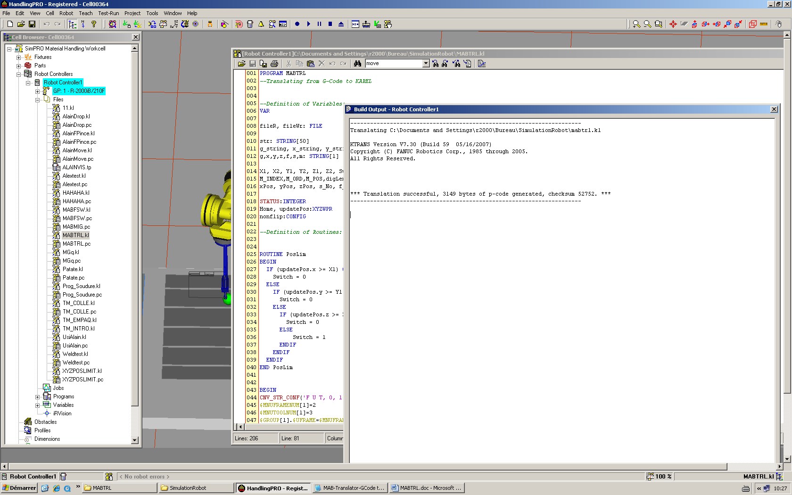

PROGRAM MABTRL
--Translating from G-Code to KAREL

--Definition of Variables:
VAR

fileR, fileWr: FILE

str: STRING[50]
g_string, x_string, y_string, z_string, f_string, s_string, m_string: STRING[8]
g,x,y,z,f,s,m: STRING[1]

X1, X2, Y1, Y2, Z1, Z2, Switch :INTEGER
M_INDEX,M_ORD,M_POS,digLength,g_No,m_No: INTEGER
xPos, yPos, zPos, s_No, f_No: REAL

STATUS:INTEGER
Home, updatePos:XYZWPR
nonflip:CONFIG

--Definition of Routines:

ROUTINE PosLim
BEGIN
IF (updatePos.x >= X1) OR (updatePos.x <= X2) THEN
Switch = 0
ELSE
IF (updatePos.y >= Y1) OR (updatePos.y <= Y2) THEN
Switch = 0
ELSE
IF (updatePos.z >= Z1) OR (updatePos.z <= Z2) THEN
Switch = 0
ELSE
Switch = 1
ENDIF
ENDIF
ENDIF
END PosLim

BEGIN
CNV_STR_CONF('F U T, 0, 1, 0',nonflip,STATUS)
$MNUFRAMENUM[1]=2
$MNUTOOLNUM[1]=3
$GROUP[1].$UFRAME=$MNUFRAME[1,$MNUFRAMENUM[1]]
$GROUP[1].$UTOOL=$MNUTOOL[1,$MNUTOOLNUM[1]]
$MOTYPE=LINEAR
$TERMTYPE=COARSE
$SPEED=1000
OPEN FILE fileR ('RO','RD:mabGcode.txt')
OPEN FILE fileWr ('Rw', 'RD:mabWrite.txt')
READ fileR (str)
--WRITE fileWr (str)
m_No = 0

X1=1000
X2=0

Y1=500
Y2=0

Z1=300
Z2=0

Switch = 1

--Defining the character variables of the text file as strings until the G-Code has not ended by a 'M02' command.
WHILE m_No<>2 DO
g='G'
x='X'
y='Y'
z='Z'
f='F'
s='S'
m='M'

--Finding and reading the 'G' characters and the digits in front of them
IF INDEX(str,g)>0 THEN --This function searchs for "g" string in "str",which is from the read G-Code file
--If it finds g, the output is its location, otherwise, the output is zero
M_INDEX=INDEX(str,g)
M_POS=M_INDEX
M_ORD=ORD(str,M_INDEX) --giving ASCI code of the intended character related to its location in "str" string
WHILE M_ORD<>32 DO --finding and reading process continous until it reachs a space --ASCI code of 32
M_INDEX=M_INDEX+1
M_ORD=ORD(str,M_INDEX)
ENDWHILE
digLength=M_INDEX-M_POS-1 --Finding the lenght of digits in front of "G" character in G-Code
g_string=SUB_STR(str,M_POS+1,digLength) --giving a string contain the digits in front of the "G" character
CNV_STR_INT(g_string,g_No) --This function converts a string to integer
ENDIF

--Finding and reading the 'X' characters and the digits in front of them
IF INDEX(str,x)>0 THEN
M_INDEX=INDEX(str,x)
M_POS=M_INDEX
M_ORD=ORD(str,M_INDEX)
WHILE M_ORD<>32 DO
M_INDEX=M_INDEX+1
M_ORD=ORD(str,M_INDEX)
ENDWHILE
digLength=M_INDEX-M_POS-1
x_string=SUB_STR(str,M_POS+1,digLength)
CNV_STR_REAL(x_string,xPos) --This function converts a string to real number
ENDIF

--Finding and reading the 'Y' characters and the digits in front of them
IF INDEX(str,y)>0 THEN
M_INDEX=INDEX(str,y)
M_POS=M_INDEX
M_ORD=ORD(str,M_INDEX)
WHILE M_ORD<>32 DO
M_INDEX=M_INDEX+1
M_ORD=ORD(str,M_INDEX)
ENDWHILE
digLength=M_INDEX-M_POS-1
y_string=SUB_STR(str,M_POS+1,digLength)
CNV_STR_REAL(y_string,yPos)
ENDIF

--Finding and reading the 'Z' characters and the digits in front of them
IF INDEX(str,z)>0 THEN
M_INDEX=INDEX(str,z)
M_POS=M_INDEX
M_ORD=ORD(str,M_INDEX)
WHILE M_ORD<>32 DO
M_INDEX=M_INDEX+1
M_ORD=ORD(str,M_INDEX)
ENDWHILE
digLength=M_INDEX-M_POS-1
z_string=SUB_STR(str,M_POS+1,digLength)
CNV_STR_REAL(z_string,zPos)
ENDIF

--Finding and reading the 'F' characters and the digits in front of them
IF INDEX(str,f)>0 THEN
M_INDEX=INDEX(str,f)
M_POS=M_INDEX
M_ORD=ORD(str,M_INDEX)
WHILE M_ORD<>32 DO
M_INDEX=M_INDEX+1
M_ORD=ORD(str,M_INDEX)
ENDWHILE
digLength=M_INDEX-M_POS-1
f_string=SUB_STR(str,M_POS+1,digLength)
CNV_STR_REAL(f_string,f_No)
ENDIF

--Finding and reading the 'S' characters and the digits in front of them
IF INDEX(str,s)>0 THEN
M_INDEX=INDEX(str,s)
M_POS=M_INDEX
M_ORD=ORD(str,M_INDEX)
WHILE M_ORD<>32 DO
M_INDEX=M_INDEX+1
M_ORD=ORD(str,M_INDEX)
ENDWHILE
digLength=M_INDEX-M_POS-1
s_string=SUB_STR(str,M_POS+1,digLength)
CNV_STR_REAL(s_string,s_No)
ENDIF

--Finding and reading the 'M' characters and the digits in front of them
IF INDEX(str,m)>0 THEN
M_INDEX=INDEX(str,m)
M_POS=M_INDEX
M_ORD=ORD(str,M_INDEX)
WHILE M_ORD<>32 DO
M_INDEX=M_INDEX+1
M_ORD=ORD(str,M_INDEX)
ENDWHILE
digLength=M_INDEX-M_POS-1
m_string=SUB_STR(str,M_POS+1,digLength)
CNV_STR_INT(m_string,m_No)
ENDIF

Home=POS( 500.0, 767.0 , 200.0 , 0.0 , 0.0 , 0.0 , NonFlip )
-- making decision to continoue program or not based on the position limitation routine
PosLim
IF (Switch = 0) THEN
MOVE TO Home
ELSE
updatePos=POS(xPos,yPos,zPos,0,0,0,nonflip)
WRITE fileWr(xPos,yPos,zPos,0,0,0)

IF g_No=0 THEN
WITH $SPEED=1000 MOVE TO updatePos
ELSE
WITH $TERMTYPE=FINE, $SPEED=f_No MOVE TO updatePos
ENDIF

ENDIF

READ fileR (str)
--WRITE fileWr (str)

ENDWHILE

CLOSE FILE fileR
CLOSE FILE fileWr

END MABTRL

